*Several tips for getting high marks*

- Please attend the last lectures for both lecturers, they sure will give HINTS to the exam (i.e what questions will come out and how to answer them, other hints but please come to class)

- Since this exam is an open book, please bring both lecture notes and tutorial notes to exam hall. Some questions you might see from past year paper that can be found in tutorial questions.

- Good luck and have fun with this module 😊

Discussion Questions  
**1.Why should an entrepreneur develop a business plan?**  
A business plan serves two essential functions. First and most important, it guides the company's operations by charting its future course and devising a strategy for following it. The second function of the business plan is to attract lenders and investors.

**2.Why do entrepreneurs who are not seeking external financing need to prepare business plans?**  
The real value in preparing a business plan is in the process the entrepreneur goes through to create the plan. Although the finished product is useful, the process of building a plan requires an entrepreneur to subject his idea to an objective, critical evaluation. What the entrepreneur learns about his company, its target market, its financial requirements, and other factors can be essential to making the venture a success.

**3.Describe the major components of a business plan.**  
Although a business plan should be unique and tailor-made to suit the particular needs of a small company, it should have these major components: an executive summary, a mission statement, a company history, a business and industry profile, a description of the company's business strategy, a profile of its products or services, a statement explaining its marketing strategy, a competitor analysis, owners' and officers' resumes, a plan of operation, financial data, and the loan or investment proposal.

**4.How can an entrepreneur seeking funds to launch a business convince potential lenders and investors that a market for the product or service really does exist?**To get external financing, an entrepreneur's plan must pass three tests with potential lenders and investors: Reality test, Competitive test, and Value test. Reality test revolves around proving that a market for the product or service really does exist and it focuses on industry attractiveness, market niches, potential customers, market size, degree of competition, and similar factors. It also focuses on the product or service itself. The Competitive test evaluates the company's relative position to its key competitors, and it focuses on management's ability to create a company that will gain an edge over existing rivals. The Value test must prove that it offers a high probability of repayment or an attractive rate of return and must convince lenders and investors that they will earn an attractive return on their money.  
**5.How would you prepare to make a formal presentation of your business plan to a venture capital forum?**  
A formal presentation often is no more than just a few minutes, usually 15 to 20 minutes, 30 minutes at the maximum. A business plan presentation should cover five basic areas: (1) The company's background and its products or services; (2) A market analysis and a description of the opportunities it presents; (3) The company’s competitive edge and the marketing strategies; (4) The management team and its members’ qualifications and experience; and (5) A financial analysis that shows lenders and investors an attractive payback or payoff.

**6.What are the 5 C’s of credit? How do lenders and investors use them when evaluating a request for financing?**  
Small business owners need to be aware of the criteria bankers use in evaluating the credit-worthiness of loan applicants - the five Cs of credit: capital, capacity, collateral, character, and conditions.  
Capital- lenders expect small businesses to have an equity base of investment by the owner(s) that will help support the venture during times of financial strain.  
Capacity is cash flow. The bank must be convinced of the firm's ability to meet its regular financial obligations and to repay the bank loan, and that takes cash.  
Collateral includes any assets the owner pledges to the bank as security for repayment of the loan.  
Character- before approving a loan to a small business, the banker must be satisfied with the owner's character.  
Conditions refers to interest rates, the health of the nation's economy, industry growth rates, etc.- surrounding a loan request also affect the owner's chance of receiving funds

**2016-2017**

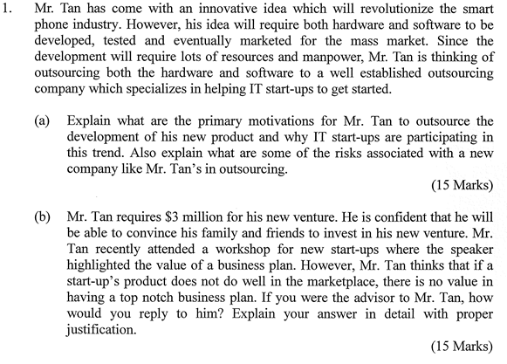

Answer:

1. (i) Primary motivations (Class Discussion 4)

* Labor cost + many raw materials are significantly cheaper
* The quality can still maintain same, if not say, better than the company does.
* Save cash for start up needed funds
* As it is a start-up, it may need to focus on its core competencies to improve the market share and profitability, so outsourcing the support activities is necessary.
* Outsourcing can help gain outside expertise and new technology that a startup may not have.

(ii) Risks involved:

* Exposing confidential data. (design of hardware, info of business idea)
* Outsourcer cannot synchronize with organization delivery schedule, delay.
* Sub standard quality
* Hidden costs.
* Outsourcer serving several organizations at the same time, lack of focus on your own organization, less incentive for perfection.

1. Business Plan (Lec 3)

Their company has not started yet, business plan mainly to attract investors, potential customers etc. It is very important for fundraising, cannot omit. For fundraising, business plan is more important. Reasons as follows.

The business plan also not only for attracting investors, it is also for Mr. Tan to look back to every aspects of his venture and to test the validity, competitiveness and value of this start up.

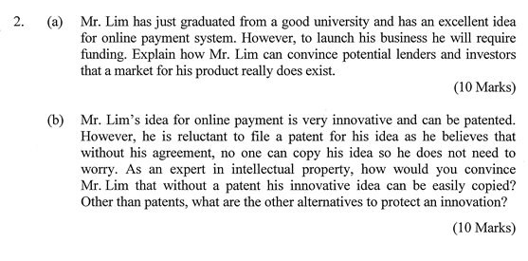

Answer:

1. Write a good business plan proving that a profitable market exists involves two steps:  
   (1) showing customer interest  
   (a) must be able to prove that their target customers need or want their goods or services and are willing to pay for them.  
   (b) offer the prototype to several potential customers in order to get written testimonials and evaluations to show to investors.  
   (c) Or the owner could sell the product to several customers at a discount.  
   (2) documenting market claims.  
   (a) Entrepreneurs must support claims of market size and growth rates with facts.  
   (b) Results of market surveys, customer questionnaires, and demographic studies lend credibility of an entrepreneur's frequently optimistic sales projections

b) Forms of protection under Australian law to consider as possible alternatives or additions to patents include:

* [trademarks](https://www.business.qld.gov.au/running-business/ip/types/trademarks) for a word or symbol that distinguishes your product or service
* [designs](https://www.business.qld.gov.au/running-business/ip/types/registered-design) for features of your innovation having visual appeal
* [confidentiality](https://www.business.qld.gov.au/running-business/ip/types/trade-secrets) agreements.
* Trade secrets
* **defensive publishing**, which requires disclosing an enabling description of an innovation so that it enters the public domain and becomes prior art. Appropriately placed defensive publications can protect your freedom to practice *without* patenting.

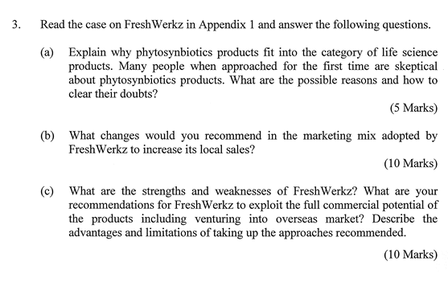

Answer:

3. (a) grab from article.

(b) Marketing Mix: (P5 marketing & sales plan)

* Product (product variety, quality, design, features, brand name, packaging, warranty, return policy)
* Price (list price, discount, credit terms, payment period)
* Promotion (public relations, advertising, sales force, direct messages)
* Place (channels, locations, inventory, fulfillment)

(c) (i) Strengths and Weaknesses: grab from article.

(ii) Going global:

Pros

* Broaden horizons (culture mix, add strength to company and product, product appealing to international customers)
* Increased brand recognition (improve future expansion opportunities, recruit locally, negotiate better deals with stakeholders, help marketing)
* Increased sales.
* Greater global market share.
* More resilient to changing markets.

Cons

* Difficulty in coordination because of different time zones.
* Language barrier
* Forex risk eats away profits.
* Political issues.
* Have to come up with new market research and strategy differentiation for that market.

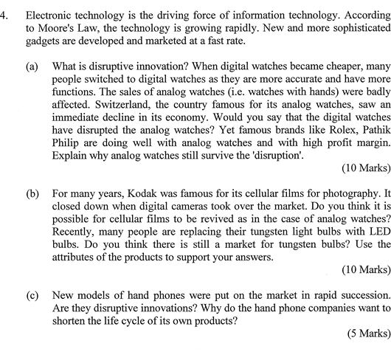

1. In [business](https://en.m.wikipedia.org/wiki/Business_administration) theory, a **disruptive innovation** is an [innovation](https://en.m.wikipedia.org/wiki/Innovation) that creates a new [market](https://en.m.wikipedia.org/wiki/Market_(economics)) and [value network](https://en.m.wikipedia.org/wiki/Value_network) and eventually disrupts an existing market and value network, displacing established market-leading firms, products, and alliances.

“A technology that significantly alters the way that businesses operate. A disruptive technology may force companies to alter the way that they approach their business, risk losing market share or risk becoming irrelevant. Recent examples of disruptive technologies include smart phones and the e-commerce retailing.

A disruptive technology does not have to be better than those currently offered by the market, and may damage the overall market to some extent by existing. For example, the advent of e-commerce retailing has led consumers to buy products online rather than their store, with online options often carrying lower prices. This has benefited consumers but made it much more difficult for producers and brick-and-mortar stores to maintain profitability.”

+ Based on the above definition, I believe that the digital watch is not a disruption to the analog watch, as it does not create a new market and not in the lower price-range to analog.

+ Why analog watches still survive the disruption:

**Aesthetics and elegance**

This is the most important factor for the majority of people and the main reason why analog watches are still in use today. Digital watches simply cannot match up to their counterparts in this department**.**Not only are analog watches much more aesthetic by themselves, they will most often fit much better with the rest of your outfit.That’s not to say that it will fit with any piece of clothing, but you can always find a watch that will go with your attire. On the other hand, a digital watch will almost always stand out like a sore thumb. Some of the most popular digital watches, while certainly looking impressive, cannot match up to the charm and elegance of some of the more popular analog watches.

Besides, using analog watches from famous brand like Rolex gives people a sense of eliteness, high-level. With the expensive design with diamonds/golds embedded in the watch, the owner may gain an admirable look from others.

All in all, here are some advantages of using analog watches:

* Analog watches have more elegant look
* An analog timepiece comes with sophisticated wrist termination
* Analog watches are special for all kinds of events
* Analog timepieces are highly durable that digital watches due to their harder materials
* Analog watches come with greater design variety than digital timepieces.

1. I don’t think it is possible for cellular film and tungsten light bulb to revive its market due to their attributes:

+ Cellular film is difficult for processing, with waiting time takes about 1-2 days. While now people who took picture want to keep their photo either in phone and in camera and want to check immediately. It also saves more cost and allows for more convenience for buyers of digital cameras as they don’t have to go to dark rooms or have to buy cellular films together with the camera. Considering even more people are buying phone with functional cameras, it is becoming more difficult for cellular films to gain back its position.

|  |  |
| --- | --- |
| Tungsten lightbulb | LEDs |
| Uses 60 watts per 10 LED watts | Uses over 5x less energy |
| Last only a few months | Last 25x longer |
| Cost $200+ over 20 years | Cost 6x less |
| Only few buying options | Comes in great variety (designs, colors,..) |

1. New models of phone are NOT disruptive innovation as rather than offering a new market and new product that interrupts the current market, it adds more features and more functions to the current handphone. Manufacturers either changes or updates the handphone rather than creating something new.

Hand phone companies want to shorten life of the product cycle as handphones are very competitive market whereby new features are invented on a daily basis and companies have to run continuously to catch up with their competitors. Besides, that is the way for them to earn more money to make their current phones outdated (by slowing them down or not providing regular software updates (iPhone cases)) and attract customers to buy new ones, though the new ones have a few extra features only. Customers are then forced to buy new models, either because of “FOMO” (fear of missing out, especially those who always want to stay on trend) or because their current phone is working too slow.

**2017 - 2018**

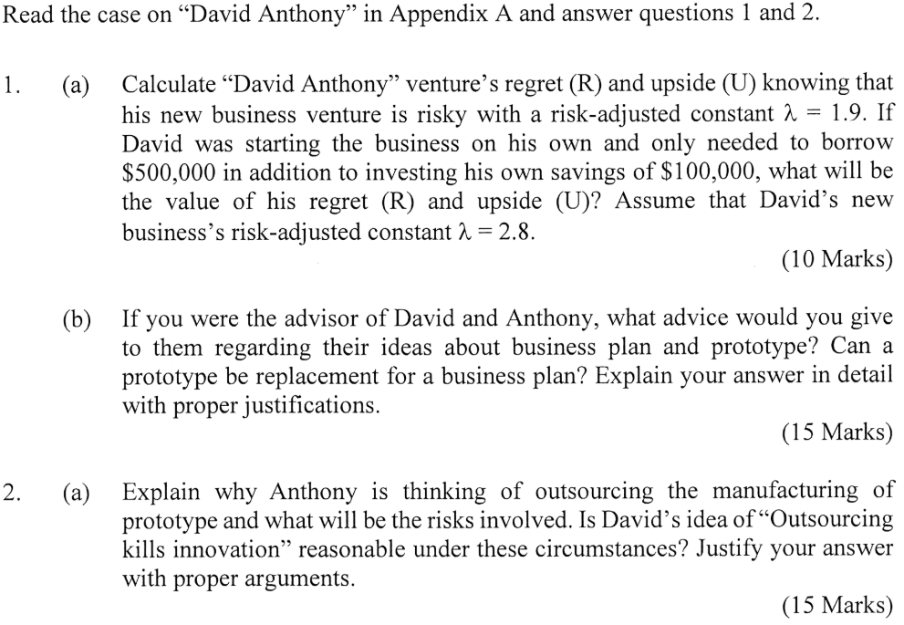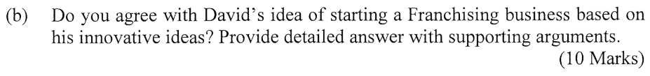

1. (a) (i) R = $ 100,000 * 2 + $500,000 = $700,000. U = R* 1.9 = $1,330,000.

(ii) R = $500,000 + $100,000 = $600,000, U = R*2.8 = $1,680,000

(b) Their company has not started yet, business plan mainly to attract investors, potential customers etc. It is very important for fundraising, cannot omit. Prototype is also important, since it gives a straightforward view of what the business idea is about, more intuitive. But none can replace each other. For fundraising, business plan is more important. Reasons as follows.

The first step in business plan is to find out market opportunity that indeed fills a need and provides value to customers. A thorough study should be done at this stage, thorough market research, consumer research, important for prototype development, know what features to include, what to discard. It also convinces investors the idea is a solid idea. Business plan also tells what the business will be, the outlook, future trends etc. Business plan also forces them to put idea through three tests: reality test - is there really market for this idea, competitive test - what will be company’s relative position in the market, and value test - what return the venture can offer to investor. For investor, value test is very important, because you have to show them in the business plan all costs involved and the market plan, how you going to finance the business, and what is your estimate of projected earnings. With these info, it will be more convincing to investors for them to invest.

While a prototype is great, it doesn’t tell the financials which is the most important element for fundraising. Moreover, ideas are easy, hard part is telling people how you make money from the idea, a business plan does just that. If you build prototype without thinking of monetizing, you will unnecessarily focus too much on features instead of thinking how to make profit. But prototype is still important, this is IT service product, important to show customers and investors how it works and sparkle their interest, more intuitive way to know whether it can be successful or not than expressing idea in black and white.

2. (a) Outsourcing is to allocate part of your business process to specialist external service provider. It has several benefits:

* Outsourcing companies have swiftness and expertise.
* Organization can concentrate on core process rather than supporting ones. (in this case, focusing on software development and hardware design, which is core. Outsource hardware manufacturing)
* Shift certain responsibilities to vendors.
* Cost saving in operational and recruitment.

Risks:

* Exposing confidential data. (design of hardware, info of business idea)
* Outsourcer cannot synchronize with organization delivery schedule, delay.
* Sub standard quality
* Hidden costs.
* Outsourcer serving several organizations at the same time, lack of focus on your own organization, less incentive for perfection.

Outsourcing Kills Innovation?

* You only outsource manufacturing. Non innovative portion.
* Core competencies do not outsource. Software development and hardware design. Innovation kept.
* Outsourcing does not kill innovation. It helps innovation by helping companies focus on key functions, better save/allocate capex, manpower, resources.

(b) - idea just idea, has not been developed into product/service yet! Cannot franchise.

* Franchise used when you alr have established business and want to expand. A method to grow business. The initial resources and financials are not a problem anymore.
* But franchise is not for fundraising.
* To start franchise, need a business that markets a product/service by franchisor.
* Business format and trade secrets are offered to franchisees.
* Parties bound by contracts.

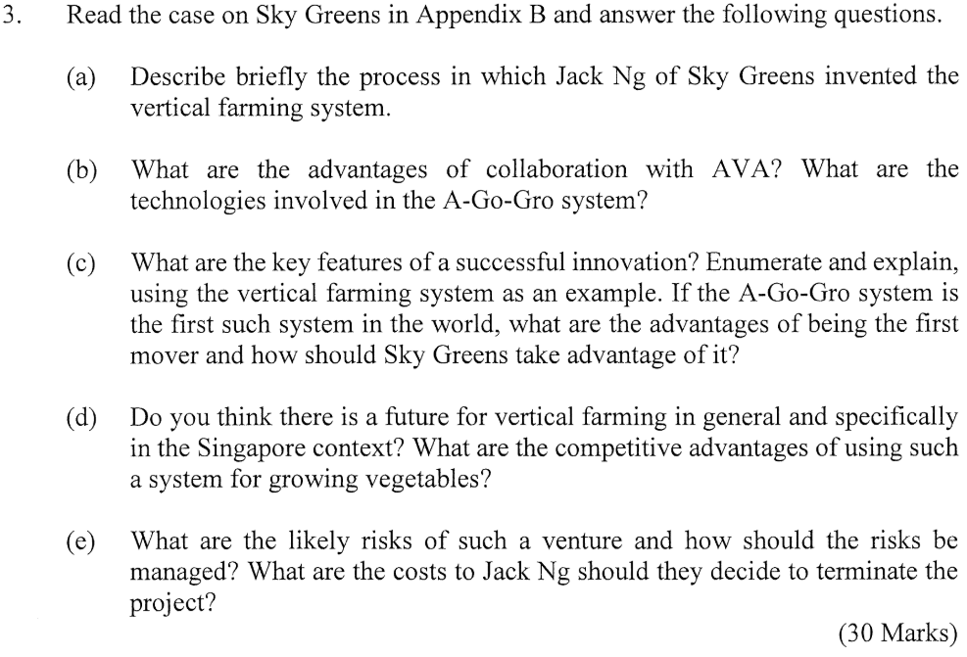

Answer: Some answer may not come from the case itself!

1. + b) Self -read and find in the case

c) Key features of successful innovation - can google / research

* better service,
* consolidation of multiple functions into one tool,
* decreased need for supplies and equipment,
* empowerment of users,
* improved interface,
* increased customizability,
* increased longevity,
* increased productivity,
* reduced user effort,
* reduced environmental impact,
* saving of money,
* saving of space or storage,
* saving of time.

Advantages of being first mover: (Lec 3 on imitation strategy)

* Create the standard and rule
* Low cost position
* Create and protect intellectual property
* Tie up strategic resources
* Increase switching cost for producer n customer

How should take advantage of it:

* In the short term, apply for patents and enhance the learning curve to create entry barrier for the latecomers
* In the long term, have a good commercialized strategy which focus on the customer
* Best utilization of resources

d) Competitive Advantage: Differentiated superior products with better quality and short delivery time keep it fresh

e) Risk (Lec 5: Technology Commercialization)

* Market risk: demand not certain
* Technical risk: Technical problems
* Competition risk
* Huge financial loss when PJ fails

How to manage risk :

* Identify source of risk and take action to minimize
* Share the risks to other parties
* Control the PJ continuously
* Adopt a stage gate approach

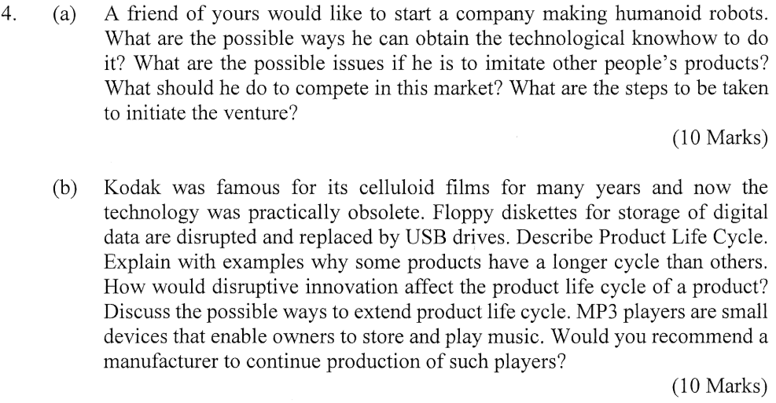

1. (i) What are the possible ways?

* Buy from company
* Learn from other company
* Outsource
* Hire engineers with technical know-how

(ii) Possible issue: Intellectual property problems

(iii) What should he do to compete in this market: Low cost strategy & Differentiation

(iv) What are the steps to be taken: (L5 Tech commercialization)

4. (b) (i) describe product life cycle. (F L5 tech commercialization)

Development - Introduction - Growth - Maturity - Decline.

(ii) explain with examples why some products have longer cycle than others.

* Extension strategy is used (price reduction, rebranding, new market, promotion, direct selling)
* Development stage takes very long.

(iii) How would disruptive innovation affect product life cycle of a product?

(iv) discuss the possible ways to extend product life cycle.

(v) would you recommend manufacturers to continue production of MP3 players?

SWOT table, might be helpful reference:

**SWOT**:

|  |  |
| --- | --- |
| Potential Strengths and Competitive Assets | Potential Weaknesses and Competitive Deficiencies |
| · Competencies that are well matched to industry key success factors  · Ample financial resources to grow the business  · Strong brand-name image and/or company reputation  · Economies of scale and/or learning and experience curve advantage over rivals  · Other cost advantages over rivals  · Attractive customer base  · Proprietary technology, superior technological skills, important patens  · Strong bargaining power over suppliers or buyers  · Resources and capabilities that are valuable and rare  · Resources and capabilities that are hard to copy and for which there are no good substitutes  · Superior product quality  · Wide geographic coverage and/or strong global distribution capability  · Alliances and/or joint ventures that provide access to valuable technology, competencies, and/or attractive geographic markets | · No clear strategic vision  · No well-developed or proven core competencies  · No distinctive competencies or competitively superior resources  · Lack of attention to customer needs  · A product or service with features and attributes that are inferior to those of rivals  · Weak balance sheet, short on financial resources to grow the firm, too much debt  · Higher overall unit costs relative to those of key competitors.  · Too narrow a product line relative to rivals  · Weak brand image or reputation  · Weaker dealer network than key rivals and/or lack of adequate distribution capability  · Lack of management depth  · A plague of internal operating problems or obsolete facilities  · Too much underutilised plant capacity  · Resources that are readily copied or for which there good substitutes |
| Potential Market Opportunities | Potential External Threats to a Company’s Future Profitability |
| · Sharply rising buyer demand for the industry’s product  · Serving additional customer groups or market segments  · Expanding into new geographic markets  · Expanding the company’s product line to meet a broader range of customer needs  · Utilizing exercising company skills or technological know-how to enter new product lines or new businesses  · Falling trade barriers in attractive foreign markets  · Acquiring rival firms or companies with attractive technological expertise or capabilities.  · Entering into alliances or joint ventures to expand the firm’s market coverage or boost its competitive capability. | · Increasing intensity of competition among industry rivals – may squeeze profit margins  · Slowdowns in market growth  · Likely entry of potent new competitors  · Growing bargaining power of customers or suppliers  · A shift in buyer needs and tastes sways from the industry’s product  · Adverse demographic changes that threaten to curtail the demand for the industry’s product  · Adverse economic conditions that threaten critical suppliers or distributors  · Changes in technology – particularly disruptive technology that can undermine the company’s distinctive competencies  · Restrictive foreign trade policies  · Costly new regulatory requirements  · Tight credit conditions  · Rising prices on energy or other key inputs |

1. **– 2019**

1. Dr Ho, a fresh PhD graduate from a local university is very excited about his innovation, which can revolutionize the way people watch videos, both offline and online on Android based mobile devices. He has developed an APP, which allows people to watch normal videos in 3D format without wearing special glasses. So far, he has uploaded his APP on Google Play store and the initial response has been quite encouraging. Currently his APP is free of charge, however he is planning to commercialize it and extend its use for other platforms (both software and hardware). In order to start his new venture, he has initial consultations with a consultant who specializes helping new start-ups.

1. Dr Ho knows that he will require an initial capital of $800,000 in addition to investing his own savings of $200,000. Calculate Dr Ho's regret (R) and upside (U) knowing that his new business venture is very risky with a risk-adjusted constant = 4.7. Also, advise Dr Ho how he should manage risks in his new high tech start­up.

Dr Ho’s regret: R = $800,000 + $200,000 = $1,000,000.

The Upside value U = risk constant * R = 4.7* 1,000,000 = $4,700,000

How to Manage Risk (lecture 2 + Revision note 2):

**Managing Risk and Uncertainty (Feedback Loop)**

1.Start by identifying the risks and uncertainties *(what are the possible sources of risk)*

2.Choose/Adjust the business strategy to reduce risk *(marketing/price etc)*

3.Choose Venture *(right actions)*

4.Actively manage *(monitor)* the venture

5.With the outcomes, manage the outcome

6.Learn from the outcomes *(strategies and actions)*

7.With new information obtained, becomes the knowledge *(market, venture, customers)*

First step is to identify as many risks as possible for the upcoming project with the knowledge that you can never see them all. **Risk identification is not a one-time process but should be a continuous process** of team members and stakeholders looking for new issues that may affect the success of the project.

Risk identification techniques: **Brainstorming, Interviews, SWOT analysis**

For example:

***Risk 1: There is no market for the product***

- Manage the risk by **doing extensive market research** before committing significant resources to the project

***Risk 2: The cost of R&D*** *goes well beyond the budget due to design changes and re-engineering*

- Getting **customers and other functional areas of the company involved in product design** at the earliest stages, and **prototyping of the product** will help to keep R&D within budget.

***Risk 3: It takes too long*** *to develop the product and get it to the market*

- Some ways to reduce cycle time include using project management tools to uncover potential bottlenecks that might delay processes; setting realistic goals and make the team accountable for its performance.

1. Dr Ho has been advised by the consultant that in order to raise $800,000 capital, he will require to prepare a business plan, however Dr Ho would like to spend that time improving his APP rather than writing the business plan. Dr Ho also thinks that since his APP has already over 1000 downloads; this proves that there is demand, so he does not need a business plan to raise money, as this is a good proof to convince the investor to invest in his new start-up. If you were the advisor of Dr Ho, what advice would you give to him regarding preparing the business plan? Explain your answer in detail with proper justification.

(15 Marks)

(Lecture 3 - Venture and Business Plan + Revision Note) This question will definitely come out in exam (as per last 3 years questions, but it is easy and already answered in the lecturer’s note and revision note.

The first step in business plan is to find out market opportunity that indeed fills a need and provides value to customers. A thorough study should be done at this stage, thorough market research, consumer research, important for prototype development, know what features to include, what to discard. It also convinces investors the idea is a solid idea. Business plan also tells what the business will be, the outlook, future trends etc. Business plan also forces them to put idea through three tests: reality test - is there really market for this idea, competitive test - what will be company’s relative position in the market, and value test - what return the venture can offer to investor. For investor, value test is very important, because you have to show them in the business plan all costs involved and the market plan, how you going to finance the business, and what is your estimate of projected earnings. With this info, it will be more convincing to investors for them to invest.

*No guarantee for success but without a BP, rate of failure becomes extremely high*

- Inside firms, like a roadmap *(to see if business can work)*

- Outside firms, used to attract investors and other stakeholders.

**Roadmap of a BP**

1. Opportunity that must be realistic and not idealistic

2. Solution: can be a product of service

3. Context, Strategy and Horizon

4. Organizational, financial and other resources available/needed

5. Financial return to participate and the risk

The current APP that has 1000 downloads is only an indicator that the APP has potential, not to mention that currently it is free, hence many people want to try them out. A successful app may have up to millions of downloads. By writing a Business Plan, he can understand more on the current market, his competitors, keep track on the finance and time needed, which customers and price to target. All in all, without a proper BP, it's like walking in darkness without knowing what to achieve, and thus not knowing how to achieve. It is also for parties who will be lending you money. The BP will allow them to understand if the owner is going to meet their requirements and objectives.

1. (a) In Question 1, Dr Ho has applied for a patent; however, his patent application is still under review. As an expert in the intellectual property (IP) management, do you think that Dr Ho should have put his APP on Google Play at this stage? What are the various options available for him to protect his radical innovation and how he can legally challenge the imitators if they copy his innovative APP?

As the patent application is underway and not approved yet, it is not recommended for Dr Ho to put his APP on Google Play at this stage as it will be very quickly imitated by copycats.

The best way for him to protect his innovation is to apply for patent, which is already underway. Another way is to trademark the name of the company that going to develop the APP and the name of the APP itself. He also should seek for legal assistance (extremely important before getting a patent).

Forms of protection under Australian law to consider as possible alternatives or additions to patents include:

* [trademarks](https://www.business.qld.gov.au/running-business/ip/types/trademarks) for a word or symbol that distinguishes your product or service
* [designs](https://www.business.qld.gov.au/running-business/ip/types/registered-design) for features of your innovation having visual appeal
* [confidentiality](https://www.business.qld.gov.au/running-business/ip/types/trade-secrets) agreements.
* Trade secrets
* **defensive publishing**, which requires disclosing an enabling description of an innovation so that it enters the public domain and becomes prior art. Appropriately placed defensive publications can protect your freedom to practice *without* patenting.

1. Entrepreneurs often have distorted picture of their business and their environment, however entrepreneur-learning process, which relies on feedback to adjust to a challenging world, can be used at various stages of a new venture to achieve the desired business goals and results. Thus, explain how Dr Ho (in Question 1) can use the entrepreneur learning process to adopt and improve his new high tech venture. Also, explain how Apple Inc. used entrepreneurial learning process for iTunes.

Apple’s Entrepreneurial learning process for iTunes (Tutorial 3). The same can be applied to Dr Ho (The answer is very long so I copied the Apple’s one to Dr Ho’s case). The actual table can be found below.

*Apple’s Entrepreneurial learning process follows closely to the table above. iTunes is a good example.*

*Apple* ***identified the problem*** *or opportunity in the digital musics industry*

*Apple* ***analysed the problem*** *or opportunity that exists between the reality of digital music downloading and the music industries interests*

*Apple* ***generated potential solutions*** *in the form of iPod*

*Apple* ***selected a solution*** *and created a plan in the form of iTunes*

*Apple* ***implemented the selected plan*** *by securing cooperation of the music industry*

*Apple then* ***evaluated the outcome*** *and learnt that the results by expanding iTunes to work with Windows*

*Apple* ***developed a relationship*** *with its key distributors which brought success.*

**The Entrepreneurial Learning Process**

|  |  |  |
| --- | --- | --- |
| ***Step*** | ***Question*** | ***Outcome or Action required*** |
| 1. Identify the problem or opportunity | What do we want to change? | Desired specific result |
| 2. Analyse the problem or opportunity | What is the key cause of the problem? | Key cause identified |
| 3. Generate potential solution | How can we make a positive change? | A list of possible solutions |
| 4. Select a solution and create a plan | What is the best way to do it? | Establish criteria, select the best solution and set a plan to accomplish it |
| 5. Implement the selected plan | How do we implement the plan effectively? | Monitor the implementation |
| 6. Evaluate the outcome and learn from the results | How well did the outcome match our desired result? | Verify that the problem is solved. Why did it work? |

1. Read the write up in Appendix A and answer the following questions.

The topic of this type of question will be announced in last lecture of the course (week 12-13). There is no need to worry, you just need to go back and do some research on the topic and bring to the exam 😊 The below answer will just serve as a simple guide.

1. Spoken language translators have now achieved an accuracy that is good enough for every day conversations. What are the technological advances that brought about this possibility? Who did the actual research work and who paid for these developments?

A speech translation system would typically integrate the following three software technologies: automatic speech recognition (ASR), machine translation (MT) and voice synthesis (TTS).

In 1983, NEC Corporation demonstrated speech translation as a concept exhibit at the ITU Telecom World (Telecom '83).

In 1999, the C-Star-2 consortium demonstrated speech-to-speech translation of 5 languages including English, Japanese, Italian, Korean, and German

1. Other than simple translation from one language to another, what are the other applications that you can think of? Give reasons why travel agencies and organizers of international meetings are potential customers. Suggest any other groups of potential customers.

Other applications: translations of broadcast news, parliamentary speeches, academic lectures, telephone conversations, and meetings…

Travel agencies and orgarnizers are potential customers since they will have to deal with a large number of individuals who come from different countries and speak different languages. Of course, they include old people or those who have difficulty to learn English, hence the translators will bring about great benefits. Other potential customers may have businesses that extending to other countries, language learners, …

1. If translation APPs can be downloaded and used with no charge, why would people want to buy dedicated hardware translators? What are other ways to persuade potential customers to buy the hardware translators?

Because there are a lot of people prefer hearing rather than reading the translated documents. Nowadays many online newspaper, although free, still provide a listen-able version of the texts for better information communication. Besides, the hardware translator provides almost at-the-same-time translation parallel with the people speaking, so it is more like a micro. Lastly, there are people with difficulty using technological stuff (phone/apps…) and even if the APP is free, sometimes it needs Wifi/4G to translate and these internet connections are not available everywhere.

1. What is your assessment for the market potential for hardware translators? Assume that the products are lucrative, and you want to make money from such hardware translators, how would you proceed? What would you do to compete with established products?

LECTURE: TECHNOLOGY COMMERCIALIZATION

1. **Before starting on Commercialization**

Do planning and preliminary assessment

1. **On the market aspect**: customers, market, industry

- Industry Analysis: Michael Porter five forces

- Market Research and Analysis: Demand, target customers, market size, trends.

- Business Model: How will your product make money? When will it be profitable? Value proposition, revenue stream, cost structure etc

2. **On the technical aspect**: technical expertise

- Technical capabilities of the company especially in the development of prototype

- Technical development is left in the hands of the experts most of the time

3. **On the financial aspect**: business model / financial planning

4. **On the legal aspect**: intellectual properties.

1. **Starting on Commercialization (Adopting Stage-gate approach)**

1. Concept formulation

2. Development: Marketing, R&D

3. Testing/Trial

4. Product launch

4.

* + - 1. (i) What is a disruptive innovation? Give an example of disruptive product. What are the implications to the company producing the disrupted products?

In [business](https://en.m.wikipedia.org/wiki/Business_administration) theory, a **disruptive innovation** is an [innovation](https://en.m.wikipedia.org/wiki/Innovation) that creates a new [market](https://en.m.wikipedia.org/wiki/Market_(economics)) and [value network](https://en.m.wikipedia.org/wiki/Value_network) and eventually disrupts an existing market and value network, displacing established market-leading firms, products, and alliances. (*completely changes the way we do things (changes the way of life)*

“A technology that significantly alters the way that businesses operate. A disruptive technology may force companies to alter the way that they approach their business, risk losing market share or risk becoming irrelevant. Recent examples of disruptive technologies include smart phones and the e-commerce retailing.

A disruptive technology does not have to be better than those currently offered by the market, and may damage the overall market to some extent by existing.

Implications for the companies that produce disrupted products:

Changes the relationship with customers and take over the market share from competitors

Improves the company business model

Solve difficult operational problems.

(ii) Describe the four states of product life cycle. What types of product have longer life cycle and what types have shorter one?



There are 4 basic stages to a product life cycle: **Introduction, Growth, Maturity, Decline**

The cycle begins from the moment that the product is introduced as a concept, to the moment when it is produced in local factories. Then it continues during the time when the product becomes internationally available, loses its unique features, and eventually declines.

**1. Introduction** - This stage of the cycle could be the most expensive for a company launching a new product. The size of the market for the product is small, which means sales are low, although they will be increasing. On the other hand, the cost of things like research and development, consumer testing, and the marketing needed to launch the product can be very high, especially if it’s a competitive sector.

**2. Growth** - The growth stage is typically characterized by a strong growth in sales and profits, and because the company can start to benefit from economies of scale in production, the profit margins, as well as the overall amount of profit, will increase. This makes it possible for businesses to invest more money in the promotional activity to maximize the potential of this growth stage.

**3. Maturity** -This is when the product begins to sell so well that new contractors are needed to keep producing. During the maturity stage, the product is established and the aim for the manufacturer is now to maintain the market share they have built up. This is probably the most competitive time for most products and businesses need to invest wisely in any marketing they undertake. They also need to consider any product modifications or improvements to the production process which might give them a competitive advantage.

**4. Decline or Extinction** - Eventually, the market for a product will start to shrink, and this is what’s known as the decline stage. This shrinkage could be due to the market becoming saturated (i.e. all the customers who will buy the product have already purchased it), or because the consumers are switching to a different type of product. While this decline may be inevitable, it may still be possible for companies to make some profit by switching to less-expensive production methods and cheaper markets.



(b) Yunnan White Medicine (YWM) is a treasure of Chinese medicines. It has a unique, outstanding curing property; especially the hemostatic (stopping blood flow) effect is superior to many Western medicines. In 1998, YWM Company produced and sold the medicine in capsule form for internal consumption and in powder form for sprinkling onto the wound. In 1992, when China opened to the world, the BAND-AID (the brand of flexible fabric bandage shown in Figure 1) of Johnson & Johnson America penetrated the Chinese market. In the years that followed, BAND-AID was able to develop rapidly in the Chinese market and became a "standard" method for rapid treatment of small cuts.

In a market survey of the China Medical Journal in 2004, BAND-AID market share was 20 times that of YWM powder. From a pharmacological point of view, BAND-AID does not have medicine in the product, its success as a replacement of YWM powder can be attributed to its market concept and business model.

In 2001, YWM factory found a way to challenge BAND-AID. It sounds a little simple: the way is to add YWM powder to the flexible bandage (Figure 2) so that it is convenient to use. In 2006, Yunnan was the second largest Band-Aid brand in the Chinese market, BAND-AID market share then was reduced to 4 times that of YWM bandage.

1. Is YWM bandage a counterfeit product, an imitation product, or a disruptive   
   product? Give reasons to support your answer.

I would say that YWM is an imitation. (lec 6 Imitation strategy) Firstly, it enters the market after BANDAID but with a product that is similar to BANDAID, but more innovative and improved.

Definitely YWM is not counterfeiting (illegally imitate) since there are improvements to the BANDAID and they do not copy exactly the product of BANDAID. It is also not a disruptive product as it does not create a new market and value, nor does it change the way how we do things (it is still the original bandage but with medicine powder)

1. What did YWM Company do to address the loss of market share in 2001?

(COMPETITIVE STRATEGY)

YWM has learned from their failure and how their competitors win the market (by focusing on the market concept and business model – focusing on the convenience rather than effectiveness).

From their they have built for themselves a COMPETITIVE ADVANTAGE of Differentation (the reading does not provide information on the cost), based on their DISTINCTIVE COMPETENCIES (the YWM powder that is effective on wounds). By this way, they have created a Value to attract customer and may become a Unique Selling Point for customers.

1. Is it wise for China to open the market for BANDAID to take away market share from YWM company?

In my opinion, it is wise for China due to the following reasons:

1. It will create a competitive environment between the local companies and foreign companies, hence local companies will have to innovate, change and improve to grasp the market share. This is in the end will benefit the whole economy and the customers, as they will have different options and choose the products that are most valuable for them.

2. As per explained in part (ii), local companies will learn from the foreign companies (imitator – late entry vs first movers), from there they can imitate and make better products in terms of quality and price.